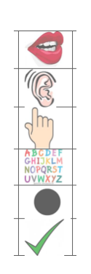
Year 2 Homework
17.9.26

Spelling – Practise your spellings every day.
Write your spellings out 5 times each. Use the next page to practise.
- sheep
- seat
- please
- been
- stream

Maths
How many tens and ones?
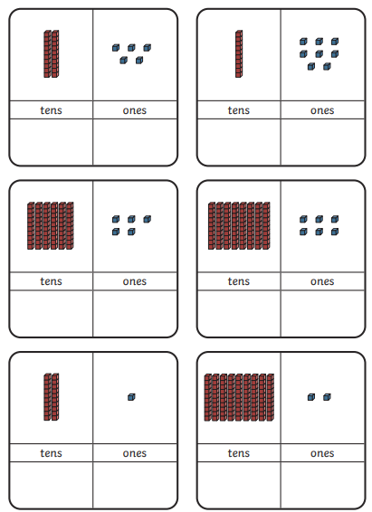


TT Rockstars
Log into TT Rockstars and have a try at playing.
https://ttrockstars.com/

