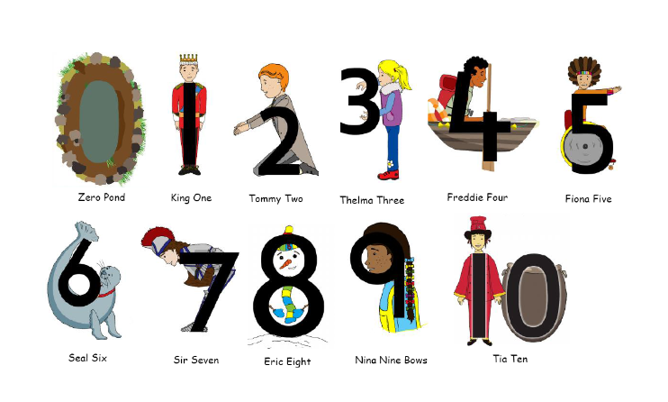
Ten Town

Zero Pond – Start at the top, nice and slow all the way round and there you go.
King One – Top to toe and there you go.
Tommy Two – Hands round to knees and straight across please.
Thelma Three - Over one hand, over the other. Put back those tarts, and don’t take another.
Freddie Four – Down, across, oar in the water.
Fiona Five – Down her back, around you go. Now arms out straight, don’t be slow!
Seal Six – Slide down his tail, curl under his nose, nearly there so strike a pose!
Sir Seven – From his helmet to his hips. Now down to his boots with shiny tips.
Eric Eight – All the way round, don’t you stop, not until your back at the top!
Nina Nine Bows – Round her head, back to the top, down to the ground, then you stop!
Tia Ten – Draw a one and then a zero. Tia Ten is everyone’s hero!

